Product Sales Insights

I replaced all ‘NULL’ values with NA values so that they are in a suitable format. I dealt with special characters e.E.g ‘T’ by converting to 0 as trace values are not significant enough to measure. I then filled NA values with the mean for appropriate columns which I would use in my model (tavg, preciptotal, avgspeed, is_rainy_day and low_vision_day) by date for each column. The ‘tavg’ variable varies seasonally, so mean by date preserves daily patterns for reasonable inputted values.

Zeros were filtered because they reflect a separate structural process (e.g., no demand or no sales activity) rather than typical sales behaviour so they would distort a model. Applying the IQR method to the remaining positive values is suitable because it is robust to skewed distributions and reduces the influence of extreme sales outliers, making it more applicable for a model.

I created the low_vision_days variable as I believed this is a weather feature with significance in terms of its impact on sales. Shoppers may be discouraged from commuting on these days as low visibility could cause commuting problems and gloomy days tend to throw off shoppers. I used Codesum to create this variable using the weather event codes ("BR","FG","HZ") representing misty, foggy and hazy days respectively.
Another feature I created was is_rainy_day. I added this feature as rainy days can often negatively affect units sold as customers may be discouraged from leaving the house and commuting could be a struggle. Additionally, the products are weather sensitive so including this feature can help in establishing a clear relationship between units sold for normal days and rainy days.

RMSE and MAE for LM and DT models:
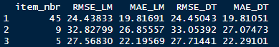
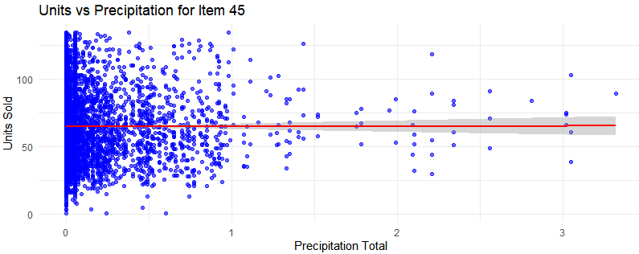This scatter plot displays units sold against total precipitation, with most observations clustered at low precipitation levels. The slightly positively sloped trend line suggests a weak positive relationship between precipitation and units sold in this case, indicating that the higher the precipitation, the slightly higher the units sold.

For item 45, Linear Regression and Decision Tree performed almost identically (RMSE 24.43 : 24.45 , MAE 19.82 : 19.81), meaning the difference between expected and actual values for both models was similar, so we favour Linear Regression for interpretability. The highest coefficient (1.25) was associated with the variable ‘preciptotal’, suggesting that precipitation impacts sales the most between the weather factors.For each additional inch of precipitation, sales of item 45 on average increases by 1.25 units keeping all other factors constant.

Business Recommendations: Slightly increase stock as expected rainfall increases in order to meet the slight demand increase to boost sales. Each additional inch of expected precipitation should be accompanied by an increase of stock by 1.25 units on average. Inventory planning should account for weather forecasts to optimize shelf space and minimize losses. Monitor rain forecasts and adjust inventory levels accordingly, prioritizing delivery and stock for rainier days.

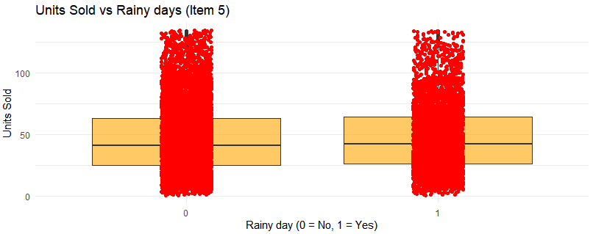The chart shows each point where units were sold for rainy and non-rainy days. Item 5 sells slightly more units on rainy days (1) than on non-rainy days (0), with a modest upward shift in the median. However, the distributions largely overlap, indicating high variability and a relatively small effect on units sold.

For item 5, Linear Regression outperforms the Decision Tree slightly. (RMSE 27.57 : 27.71, MAE 22.20 : 22.29), MAE and RMSE are very similar for the regression model compared to the decision tree model so we favour the LM model for interpretability.
Examining the LM coefficients shows that rainy days (is_rainy_day) have the largest weather-related effect on sales (0.74) ,indicating that on rainy days (1) compared to non-rainy days (0), units sold is on average 0.74 units higher, holding all other variables constant.

Business Recommendations: Rainy days are associated with a small positive lift for item 5 and could be accompanied by an increase in stock of item 5 by 0.74 units on average. A modest but positive lift. From a business perspective, rainy days should not trigger major inventory or staffing changes for Item 5, but they can be treated as a light demand tailwind. Managers could pair rainy-day conditions with low-cost nudges such as subtle promotions, cross-selling with complementary “rain-friendly” items, or digital reminders to capture incremental sales without over-investing.

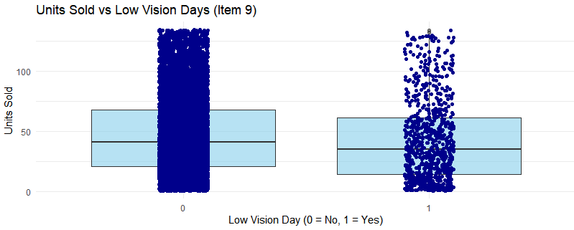
The chart compares daily units sold for Item 9 between normal-visibility days (0) and low-visibility days (1) using box plots with individual sales observations overlaid. The boxes summarize the distribution of sales for each group, while the dots represent each day’s actual units sold. The chart shows that Item 9 consistently sells fewer units on low-visibility days compared to normal-visibility days, with a lower median and an overall downward shift in the distribution. It also indicates fewer high-sales days when visibility is poor, suggesting both average demand and upside potential are reduced.

For the model for Item 9, Linear Regression outperforms the Decision Tree slightly. (RMSE 32.83 : 33.05 , MAE 26.86 : 27.07), MAE and RMSE is similar for the regression model compared to the decision tree model so we favour the LM model for interpretability. Examining the LM coefficients shows that low_vision_days has the largest effect on sales (-4.28) , indicating that on low-vision days (1) compared to non-low-vision days (0), units sold is on average 4.28 units lower, holding all other variables constant.

Business Recommendations: Unlike Item 5, which shows a small positive response to rainy conditions, Item 9 experiences reduced demand on low-visibility days, reinforcing that weather effects vary by product. Decreasing stock levels of Item 9 on low-visibility days could help avoid overstocking, maximizing revenue and minimizing loss. Planners can systematically adjust ordering, staffing, and promotional calendars for expected days of low visibility and should be accompanied by a decrease in stock of Item 9 by 4.28 units on average for low-visibility days. Marketing or promotions could also be targeted on foggy, misty or hazy days to accommodate for the drop in units sold for these days.

